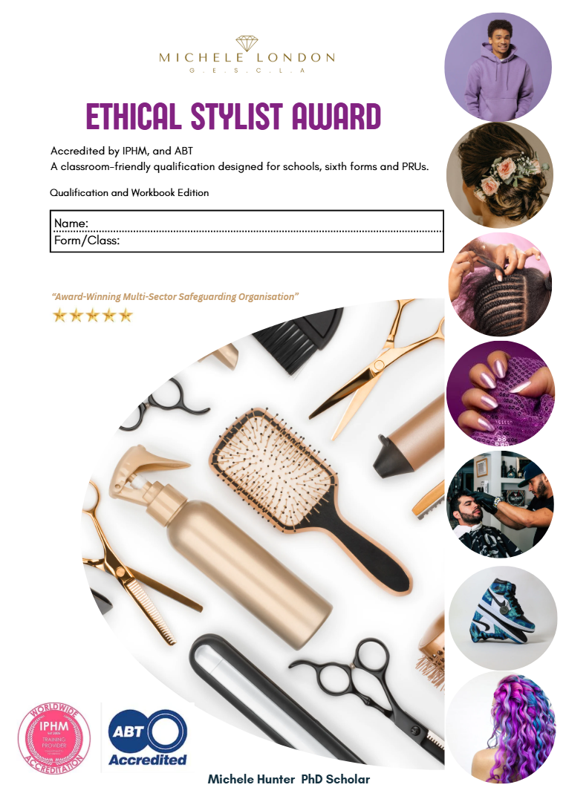

Teacher Guidance Notes – The Ethical Stylist Workbook

📘 About this Workbook
The Ethical Stylist Workbook is a flexible qualification resource that can be delivered in schools, sixth forms, PRUs, alternative provision, or through home learning. It covers barbering, hair, beauty, fashion styling, self-care, sustainability, and safeguarding awareness.
No formal lesson planning is required. The workbook is designed to be self-guided with activities, reflection tasks, and verification charts. Any teacher, TA, or cover supervisor can deliver it using the guidance notes provided.

📝 How to Deliver
Each module should take around 45–60 minutes.
Learners may work independently, in pairs, or small groups.
Encourage discussion, creativity, and reflection.
At the end of each module, ensure learners complete their reflection questions and practical activities. Teachers/mentors should sign the Verification Chart once modules are complete.
📌Key Notes for Teachers
Module 1 (Health & Safety) and Module 2 (Client Care & Communication) must be completed first.
Modules 3–12 can be completed in any order, depending on timetabling and learner needs.
Use the Post-it Note Recap reminders to check understanding and build continuity.
Practical tasks (e.g. barbering, nails, fashion design) can be adapted using mannequins, drawing templates, or low-cost materials if specialist tools are unavailable.
Safeguarding and ethical principles (body shaming, sustainability, self-care) should be reinforced in every session.

✅ Assessment & Verification
Assessment is built into the workbook through reflection tasks, quizzes, and creative activities. Teachers do not need to create separate assessments. Verification is completed using the Verification Chart at the back of the workbook.
Only the completed Verification Chart needs to be returned to GESCLA for certification.
GESCLA may request sample pages for quality assurance.
Each learner will then be issued an Accredited Certificate of Achievement (ABT & IPHM).

🌟 Tips for Successful Delivery
- Allow learners to showcase their creativity through posters, mood boards, and styling templates.
- Encourage positive feedback between peers to build confidence.
- Emphasise ethical and safeguarding values throughout.
- Link activities to real-world careers (barbering, beauty retail, sustainable fashion, entrepreneurship).

Student Kits
All activities can be adapted with basic classroom materials if specialist items aren’t available. Explore Amazon and High Street stores for cost effective add On’s if necessary. Teachers/TAs can supervise, no specialist beauty qualifications are required. Schools can start small (basic nail kits, mannequins, face masks) and build up resources as needed. These items support learners in completing practical activities across modules. Schools can adapt to what they already have.
Barbering & Hair
- Training scissors (safety scissors acceptable for enrichment groups)
- Clippers (5 classroom sets or teacher demo)
- Combs and sectioning clips
- Spray bottles (water only)
- Mannequin training heads (male & female) ( 2 bald for line up and hair fibre practice)
- Neck brushes / small hand brushes (check clipper kits as included free)
- Barber Cape / Gown (check clipper kits as included free)
- Hair Rollers / Flexi Rods – for creative styling (optional but fun)
- Barber Comb Set (different sizes, especially for fades)
- Styling Products Variety – mousse, serum, leave-in conditioner (so learners see different types)
- Hair Dryer, straighteners, Curling Iron

Beauty & Self-Care
- Nail files & buffers (1 per learner)
- Nail polish (Base, topcoat, 6 basic colours)
- Nail Art Kits
- Mini Nail Dryers (optional)
- Cotton pads & nail polish remover (acetone-free for school use)
- Towels or disposable tissues
- Face mask sachets (cheap, safe options – e.g. clay, cucumber)
- Headbands or hair ties
- Cuticle Oil / Cuticle Sticks – for nail care basics
- Hand Cream / Moisturiser – to finish nail/self-care activities
- False Nail Practice Wheels – so learners can do art without needing models
- Makeup Sponges / Brushes (disposable options) – for hygiene
- Compact Mirror (1–2 classroom sets, optional
- All in One Make up Kits - (Amazon)
Fashion Styling & Design
- Fashion sketch templates (provided in workbook)
- Colouring pencils / felt tips
- Magazines or printouts for collage/mood boards
- Glue sticks, scissors, A3 paper/card

Self-Care & Wellbeing
- Yoga mats or floor mats (optional for stretching/relaxation activities)
- Colouring sheets / mandalas for mindful relaxation (if some don’t want to do face masks)
- Reusable water bottles / cups (hydration linked to self-care)
Hygiene & Safety (important for safeguarding)
- Disposable Gloves (optional, for nail/henna tasks)
- Aprons (plastic/paper for beauty treatments)
- Disinfectant Spray for tools/surfaces
- Paper Towels / Tissue Roll (quick clean-up)
- First Aid Kit nearby (standard safeguarding requirement for any practical activity

Weekly Programme
Week | Theory (10 mins) | Practical (40–45 mins) | Barbering Focus | Beauty / Other Focus
1 | Health & Safety; Tools Introduction | Tool handling & hygiene | Barbering basics, fades | Tool usage & sectioning
2 | Client Care & Communication | Role-play consultations | Consultations | Consultations
3 | Hair Types (straight, curly, coily) | Cutting basics on mannequins | Short styles | Blow-drying for textures
4 | Mood Boards – Part 1 | Create first mood board | Taper / fade practice | Braids & plaits
5 | Mood Boards – Part 2 | Develop advanced mood boards | Weave extensions | Styling extensions
6 | Nails & Hand Hygiene | Basic nail care & designs | Male grooming focus | Nail art practice
7 | Self-Care & Social Media Awareness | Face mask practical | Poster on grooming | Poster on self-care
8 | Business Start-Up Basics | Lash application / beauty add-on | Barbering techniques | Beauty treatments
9 | Event Styling & Charts | Prom/sports makeover | Barbering styles | Makeup & lashes
10 | Advanced Styling Theory | Updos & creative cuts | Pattern cuts | Weaves & braids
11 | Theme Planning | Plan chosen looks | Barbering practice | Hair & nails combined
12 | Refinement & Review | Final practice session | Advanced barbering styles | Final beauty looks

Ethical Styling Award - Master Verification Sheet
Student ID | M1 | M2 | M3 | M4 | M5 | M6 | M7 | M8 | M9 | M10 | M11 | M12

Teacher Declaration
I confirm that the above learners have successfully completed all required modules of the GESCLA Ethical Styling Award.
Teacher/ Support Staff Name: __________________ Signature: _____________________
Date: __________ School/Organisation Stamp (if available): _________________________
Teacher Instructions on Completion
- Check All Modules Completed
  - Ensure learners have completed all 12 modules (Module 1: Health & Safety and Module 2: Client Care & Communication must be completed first; the rest can be in any order).
  - Verify that reflection tasks, quizzes, and activities have been attempted.
- Complete the Verification Chart
  - At the back of the workbook, each module has a sign-off section.
  - Teachers/TAs must tick or sign that the learner has completed each module.
  - Only the Verification Chart needs to be submitted — not the entire workbook.
- Collect Evidence (Optional but Recommended)
  - Teachers may take photos of mood boards, posters, or practical tasks (hair, nails, fashion sketches).
  - This supports safeguarding and quality assurance but is not compulsory.
- Verification Chart
  - Teacher completes the chart (tick for each module per learner).
  - Instead of names, each learner is given a unique student code (e.g. ES-2025-001).
  - Teacher writes those codes on the Verification Chart.

- Return to GESCLA
  - Chart is scanned/emailed back to you.
  - You check it against your register.
- Signed Certificates Issued
  - Michele London personally signs each certificate (printed on premium card with ABT + IPHM logos).
  - Each certificate carries the learner’s unique code + our signature.
  - Certificates are then posted to the school for distribution. Schools may distribute certificates at assemblies, award events, or directly in class.
- Encourage Next Steps
  - Direct learners to progression opportunities:
    - Further vocational study (college, apprenticeships).
    - Entrepreneurship pathways (mobile beauty, styling, small business).
    - Optional top-up with the Ethical Aesthetics Safeguarding Licence (CPD accredited).

